On the Benefits of Long Hikes in the Mountains

Peter Lambooij  Fontys ICT  p.lambooij@fontys.nl | Simona Orzan  Fontys ICT  s.orzan@fontys.nl | Chad Gepetti  Open AI

Abstract
Long hikes in the mountains offer a holistic experience that provides numerous benefits forphysical and mental well-being. Beyond the physical exercise, these journeys through ruggedterrain foster mental rejuvenation, a deep connection with nature, a sense of accomplishment,and opportunities for community and connection. This article explores the multifaceted advantagesof embarking on long hikes in the mountains, highlighting their transformative effectson both body and mind.
Keywords: hiking, nature, well-being, writing

Introduction
There is something undeniably enchanting about the mountains—their majestic peaks, serenevalleys, and the sense of solitude they offer. Beyond their sheer beauty, mountains provide anexcellent setting for one of the most invigorating activities: long hikes. These journeys throughthe rugged terrain offer more than just physical exercise; they provide a multitude of benefits forboth body and mind. Let’s delve into why embarking on long hikes in the mountains is not justan adventure but also a form of therapy.

Physical Fitness
One of the most obvious benefits of hiking in the mountains is the opportunity for physical exercise.The uneven terrain, varying inclines, and high altitude all contribute to a challenging workout thatengages multiple muscle groups. Unlike the monotony of a treadmill or the repetitive motion oflifting weights, hiking offers a dynamic experience that keeps both body and mind stimulated.With each step, hikers strengthen their legs, improve cardiovascular health, and enhance overallendurance.

Mental Well-being
Beyond the physical benefits, long hikes in the mountains are also profoundly beneficial for mentalhealth. Surrounded by nature’s grandeur, hikers often find themselves immersed in a sense oftranquillity that is hard to come by in the hustle and bustle of everyday life. The solitude of themountains provides an opportunity for introspection, allowing hikers to clear their minds and findinner peace. Studies have shown that spending time in nature can reduce stress levels, alleviatesymptoms of anxiety and depression, and improve overall mood. In the mountains, away from thedistractions of modern life, hikers can reconnect with themselves and find a sense of balance.

Connection with Nature and Fellow Humans
In our increasingly urbanized world, many people have become disconnected from the naturalworld. Long hikes in the mountains offer a chance to rekindle that connection. As hikers traversethrough forests, meadows, and alpine landscapes, they bear witness to the wonders of the naturalworld — from the delicate beauty of wild flowers to the raw power of cascading waterfalls. Thisimmersion in nature fosters a deep appreciation for the environment and instils a desire to protectit for future generations.
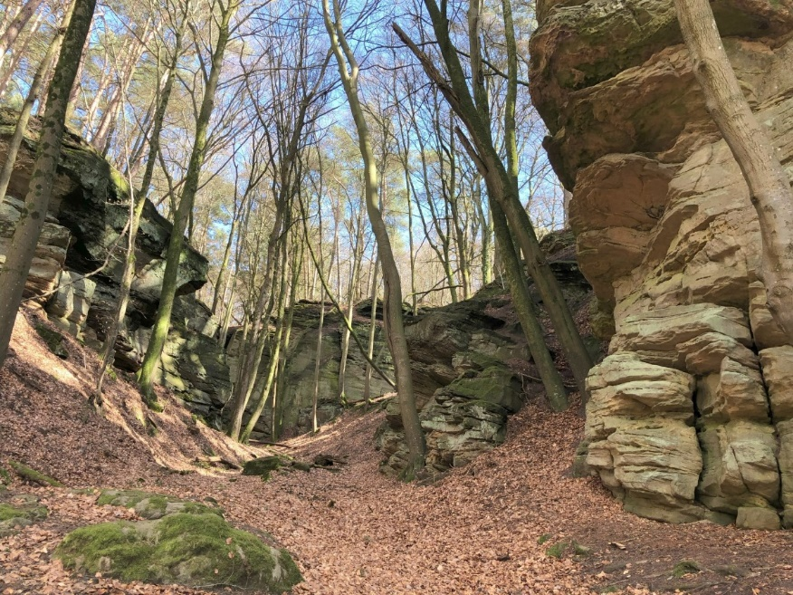
Figure 1 Landscape along the GR5, one of Europe's longest hiking trails.

While hiking in the mountains can be a solitary pursuit, it also has the power to foster connectionswith others. Whether it’s sharing stories around a camp-fire, offering words of encouragementon a difficult ascent, or simply exchanging smiles with fellow hikers on the trail, the mountainshave a way of bringing people together. These shared experiences create bonds that transcenddifferences and unite individuals in a shared love for adventure and exploration.

Eureka!
If you then get inspired to write a research paper, just do it! After you write it in your favourite editor, please try to translate it into the style of the current template, so that the readers get a unified view when browsing through the variety of FIRE articles.

How to include Figures
Just insert a picture with a caption. Center the figure horizontally. Use continuous numbering throughout the document.

How to include Tables
Center the table. Use continuous numbering throughout the document. Check the example below.

Benefit | Description
Physical Fitness | Engages multiple muscles, improves cardiovascular health.
Mental Well-being | Reduces stress, alleviates anxiety and depression.
Connection with Nature | Fosters appreciation for the environment.
Sense of Accomplishment | Provides a feeling of achievement.
Community and Connection | Encourages bonds with fellow hikers.
Table 1 An example table.

How to add Lists
Just click on the numbers – or bullets …

How to write Mathematics
Good luck with that It can be quite tedious, but works well for short formulas. Get started in 5 minutes with this tutorial. When you get tired, try LaTeX in Overleaf.

How to add Citations and a Reference List
It is best practice to maintain a References database. Select the IEEE style when generating the Bibliography from the cited sources [1, 2, 3, 4, 5].

Sense of Accomplishment
Completing a long hike in the mountains, just like writing a good report, is no small feat. Itrequires determination, perseverance, and often, a willingness to push beyond one’s comfort zone.Successfully reaching the summit of a mountain or completing a challenging trail fills hikers with aprofound sense of accomplishment and pride. This feeling of achievement can boost self-confidenceand serve as a reminder of one’s capabilities both on and off the trail.

Conclusion
Long hikes in the mountains offer a wealth of benefits for both body and mind. From the physicalchallenges of the trail to the mental rejuvenation found in nature’s embrace, hiking provides aholistic experience that nourishes the soul. So lace up your boots, pack your backpack, andventure into the mountains — you’ll be rewarded with memories that last a lifetime and a renewedappreciation for the beauty of the world around you.

References
[1] S. Kaplan, “The restorative benefits of nature: Toward an integrative framework,” Journal ofEnvironmental Psychology, vol. 15, no. 3, pp. 169–182, 1995.
[2] J. T. Coon, “Does participating in physical activity in outdoor natural environments have agreater effect on physical and mental wellbeing than physical activity indoors? a systematicreview.,” Environmental science & technology, vol. 45, no. 5, pp. 1761–1772, 2011.
[3] J. T. Neill, “Adventure education and resilience: The double-edged sword.,” Journal of AdventureEducation & Outdoor Learning, vol. 1, no. 2, pp. 35–42, 2001.
[4] J. Pretty, “The mental and physical health outcomes of green exercise.,” International Journalof Environmental Health Research., vol. 15, no. 5, pp. 319–337, 2005.
[5] D. K. Thomsen, “Age and gender differences in negative affect—is there a role for emotionregulation? personality and individual differences.,” Journal of Environmental Psychology,vol. 38, no. 8, pp. 1935–1946., 2005.

